WINNEBAGO COUNTY

AEROSPACE PROJECT RECORD FOR 20

Things I plan to do and learn this year in this project are: (complete this box between Jan. 1 and May 1) | Check When Done
Describe launch or flight experience:

Identify model parts
CHECK SKILLS LEARNED OR IMPROVED
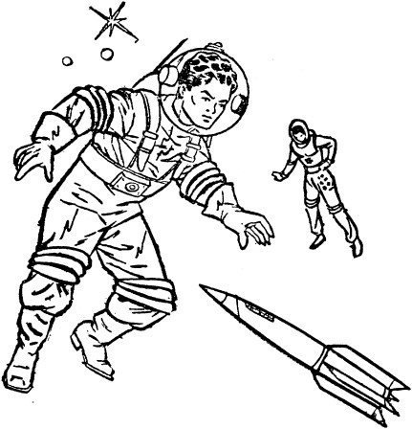Work with balsa wood models

Select a model (appropriate to skill level) Select proper tools
Read/use pattern
Understand/use aerospace vocabulary File flight plan
Build a rocket Engine assembly Apply fins
Build a model plane Build a launch pad Use glue
Apply decals Apply base paint Final finishes Measure
Sand
Use wood filler Assemble parachute Repair models after flights Build a diamond kit
Build a hot air balloon
Learn International Phonetic Alphabet Work with plastic models
Build model from a kit Design an original model Build from scratch
Learn launch safety
Launch a rocket Fly a model plane Explore careers/jobs
Tour aerospace related business
Other: please list

Ways You Received Help This Year Include: (check all that apply)
Exhibits in This Project:
Item Placing
(additional page may be added)

Attended project training offered by my club
Attended project training offered at the county level
Attended project training offered at District or State Level
Guidance from 4-H Leader/4-H Club
Guidance from Parent/Guardian/Other Adult
Reading and use of 4-H project guides
Reading and use of literature, books, audio visual resources
Own knowledge
Help from friends/other youth
Other (describe)

List at least 2 aerospace industry related careers that you can identify.
What did you learn or enjoy in the project this year?

Are you interested in a career related to the aerospace industry?
Yes_ No_ Maybe_

Project Worth Statement

What project related skill(s) would you like to learn or improve?

Has this project been worthwhile to you? Why or why not?

Revised 11/2006

