

Winnebago County

Cloverbud

Record Book

Now You Are A 4-H Cloverbud!

Congratulations & Welcome

*Updated January 2016 “Adapted from Adams County 4-H”*



*Picture*

*Of*

*You*

**Name: ______________________________**

**4-H Club: ____________________________**

**4-H Leader: __________________________**

**Years in 4-H: _________________________**

**Grade in School: _______________________**

**Name of School: _______________________**

This booklet is designed to help you keep track of all the things you will do as a

4-H Cloverbud.

The 4-H Emblem is:

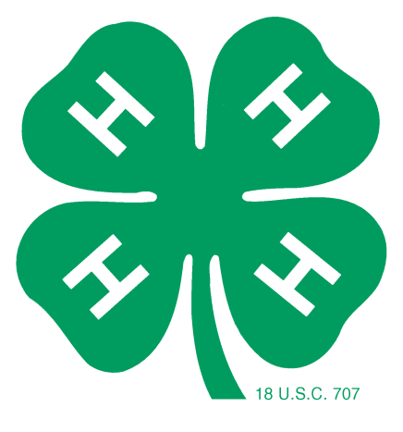A green four-leaf clover with the letter "H" on each leaf. Each "H" stands for a part of the pledge -

Head,

Heart,

Hands,

Health

The 4-H Colors Are:

Green and White.

Green symbolizes nature's most common color. White symbolizes purity.

The 4-H Motto is:

"To Make The Best Better"

This motto challenges everyone involved in 4-H to do the very best job they can.

**Flag Pledges**

The American Flag Pledge:

**USA 2**

“I pledge allegiance to the flag of the United States of America, and to the republic for which it stands, one nation under God, indivisible, with liberty and justice for all.”

(When reciting the pledge, your right hand should be placed over your heart, which is on the left side.)

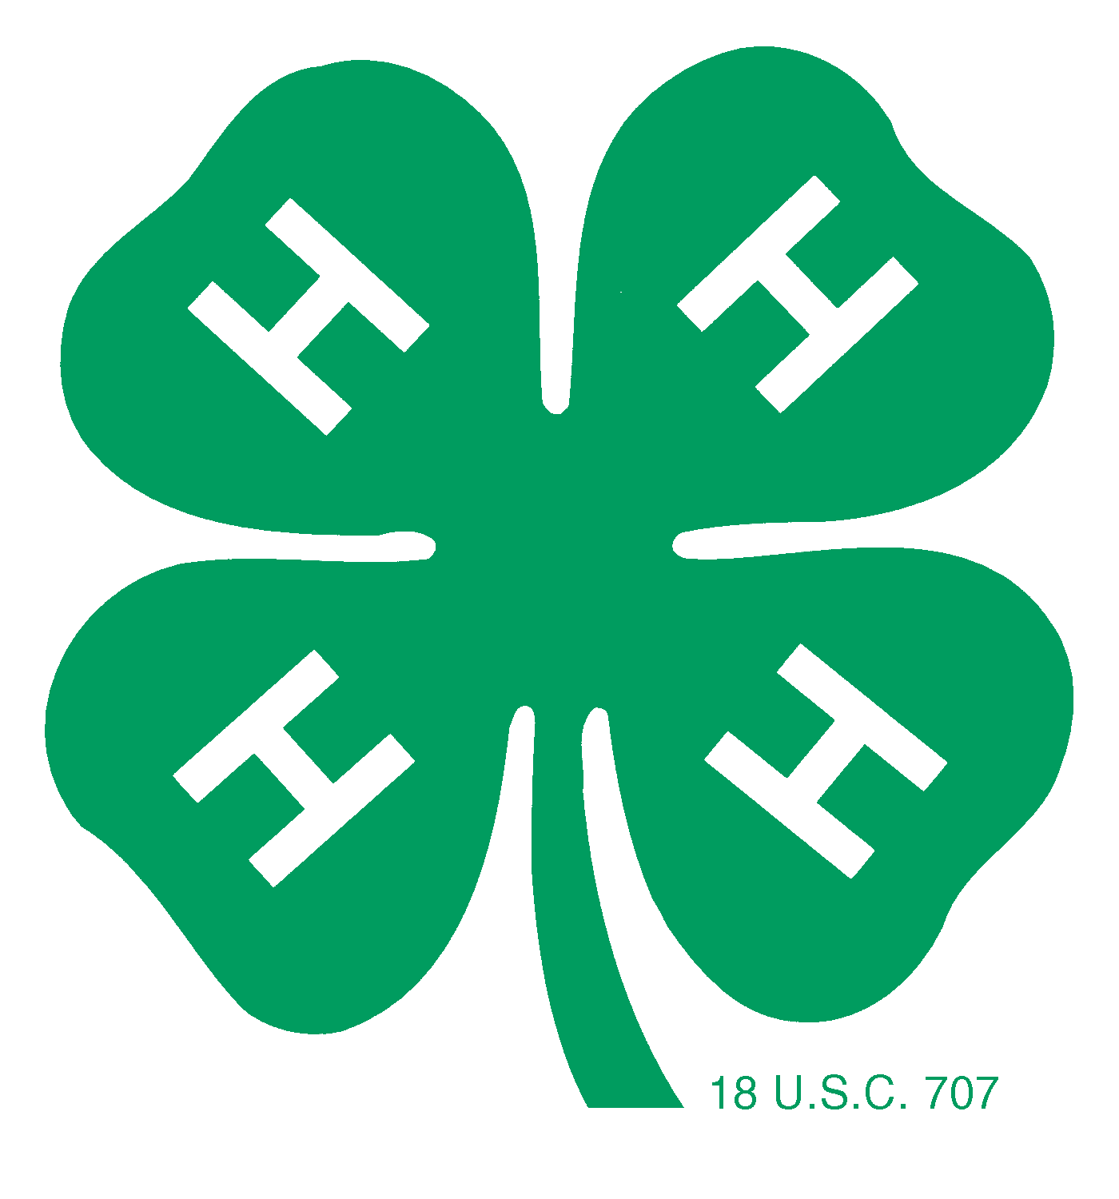

The 4-H Pledge:

I Pledge:

*(Right hand point*

*to forehead)*



**My Head** to clearer thinking

*(Right hand over heart)*



**My Heart** to Greater loyalty

*(Arms slightly bent with*

*palms up)*



**My Hands** to larger service, and

**My Health** to better living for my club, my community, my country, and my world.



*(Arms at*

*sides)*

**Cloverbud Activity Record**

Check the activities **you** participated in.

**Club Activities:**

Attended required club meeting

Attended club project meetings

Club member

Club community service

Club tour participation

Fundraising (Pizza Sale or other)

Gave demonstration at club meeting

Lead club in pledges

Parade participation for club

Recruited new members

_____ Made a new friend

Other activities (list)

____________________________________________________________________________

____________________________________________________________________________

____________________________________________________________________________

____________________________________________________________________________

**Draw or attach a picture of you at a club meeting…**

**Cloverbud Activity Record**

Check the activities **you** participated in.

**County Activities:**

Exhibited at county fair

Dipper Worker (4-H Foodstand)

Help build club booth at fair

Helped at fair (entry day, watch exhibits)

_____ Small Fry Contest

_____ New to Fair Exhibitor Night

 Cloverbud Blast (in fall)

_____ Cloverbud Camp (in summer)

Clothing Revue

Foods Revue

_____ Speaking Contest

_____ Drama Night

4-H Fun/Project Day

_____ National 4-H Youth Science Day

_____ Lego Club

_____ New to 4-H Family Night

Attended 4-H Family Banquet

Attended county project meeting

Turned in record book on time

Promoted 4-H in the community

Other activities (list):

____________________________________________________________________________

____________________________________________________________________________

____________________________________________________________________________

____________________________________________________________________________

____________________________________________________________________________

**Cloverbud Project Record**

**I went to regular 4-H club meetings.**

**I like 4-H meetings because:**

|  |
| --- |
|  |
|  |
|  |

**This year, I took these projects to the fair:**

|  |
| --- |
|  |
|  |
|  |

**My favorite project was:**

______________________________________________

______________________________________________

______________________________________________

**One thing I learned in 4-H this year was…**

______________________________________________

______________________________________________

______________________________________________

**Parent’s Comments:**

|  |
| --- |
|  |
|  |
|  |

**Parent Signature:** _________________________________________________

**Organizational Leader Comments:**

|  |
| --- |
|  |
|  |
|  |

**Organizational Leader Signature: _________________________________**

**Cloverbud Member’s Signature: ___________________________________**

**Draw or Attach**

**Pictures about**

**4-H Cloverbuds and You!**

**My 4-H Cloverbud Story**

Write what you liked about being in 4-H. What was your favorite thing? What did you do? What would you like to do next year?

|  |
| --- |
|  |
|  |
|  |
|  |
|  |
|  |
|  |
|  |
|  |
|  |
|  |

**4-H Cloverbud Supporting Material**

Add newspaper clippings, pictures, ribbons, certificates, etc. of different 4-H activities you participated in here.