WINNEBAGO COUNTY

CROPS PROJECT RECORD FOR 20

Check all that apply: Corn Small Grains
Forage

What do you enjoy most about raising crops?

What do you enjoy least about raising crops?

Ways You Received Help This Year Include:
(check all that apply)

Things I plan to do and learn this year in this project are: (complete this box between Jan. 1 — May 1) | Check When Done

Exhibits in This Project:
Item Placing
(additional page may be added)

Attended project training offered by my club
Attended project training offered at the county level
Attended project training offered at District or State Level
Guidance from 4-H Leader/4-H Club
Guidance from Parent/Guardian/Other Adult
Reading and use of 4-H project guides
Reading and use of literature, books, audio visual resources
Own knowledge
Help from friends/other youth
Other (describe)

List the types of crops raised this year.
Explain skills, techniques, tools or information learned or improved this year.

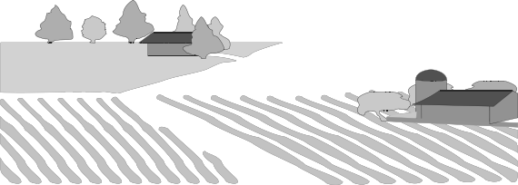List at least 2 crop industry related careers that you can identify.

Are you interested in a career related to the crop industry?
Yes_ No_ Maybe_

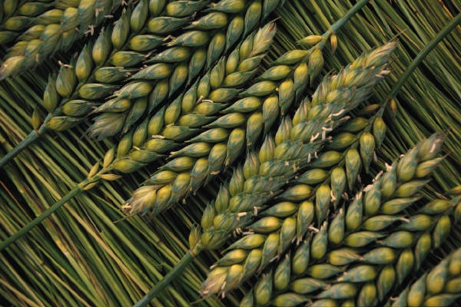

Project Worth Statement

What project related skill(s) would you like to learn or improve?

Has this project been worthwhile to you? Why or why not?

Revised 12/2007

