WINNEBAGO COUNTY

FLOWERS AND/OR VEGETABLES PROJECT RECORD FOR 20

Things I plan to do and learn this year in this project are: (complete this box between Jan. 1 — May 1) | Check When Done

Explain skills, techniques, and/or tools learned or improved this year.

Ways You Received Help This Year Include:
(check all that apply)
Exhibits in This Project:
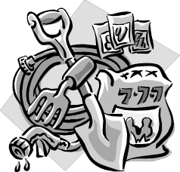Item Placing
(additional page may be added)

Attended project training offered by my club
Attended project training offered at the county level
Attended project training offered at District or State Level
Guidance from 4-H Leader/4-H Club
Guidance from Parent/Guardian/Other Adult
Reading and use of 4-H project guides
Reading and use of literature, books, audio visual resources
Own knowledge
Help from friends/other youth
Other (describe)

INDIVIDUAL RECORD
(Attach a drawing of your garden, you may also include a picture on additional page.) Include garden dimensions, varieties and placement of plants.

Expenses:

Seeds (describe) Total $
What do you enjoy most about the project?

Plants (describe) Total $

Other Plants (e.g., onion sets, potatoes, etc.) Total $ Total $ Total $

What do you enjoy least about the project?

Fertilizer  Other (describe) | Total | $
 | Total | $
 | Total | $
 | Total | $
 | Total | $

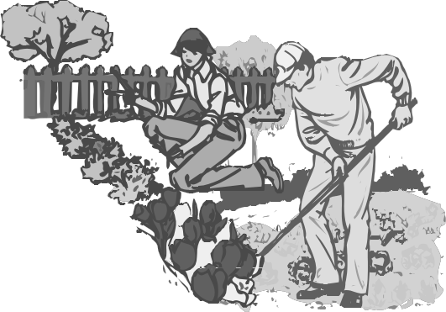List at least 2 flower/vegetable gardening industry related careers that you can identify.

Are you interested in a career related to the flower/vegetable gardening industry?
Yes_ No_ Maybe_

Project Worth Statement

Has this project been worthwhile to you? Why or why not?

Revised 11/2006

