WINNEBAGO COUNTY

HOUSE PLANTS PROJECT RECORD FOR 20

Things I plan to do and learn this year in this project are: (complete this box between Jan. 1 — May 1) | Check When Done

House plant work and cost:
Date | Work Done (Examples: violet started, planted terrarium or herb garden, etc.) | Cost/Value

Ways You Received Help This Year Include:
(check all that apply)
Exhibits in This Project:
Item Placing
(additional page may be added)

Attended project training offered by my club
Attended project training offered at the county level
Attended project training offered at District or State Level
Guidance from 4-H Leader/4-H Club
Guidance from Parent/Guardian/Other Adult
Reading and use of 4-H project guides
Reading and use of literature, books, audio visual resources
Own knowledge
Help from friends/other youth
Other (describe)

What do you enjoy most about raising house plants?

What do you enjoy least about raising house plants?

List at least 2 house plant industry related careers that you can identify.

Are you interested in a career related to the house plant industry?

Yes_ No_ Maybe_

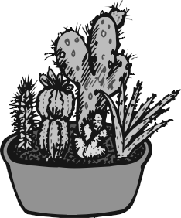

What project related skill(s) would you like to learn or improve?

Project Worth Statement

Has this project been worthwhile to you? Why or why not?

Revised 11/2006

