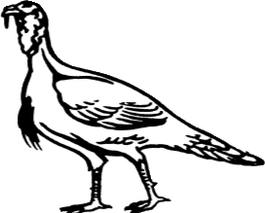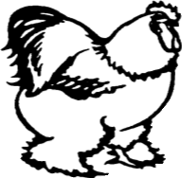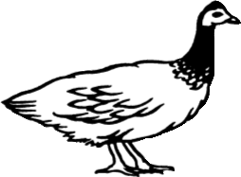WINNEBAGO COUNTY

POULTRY PROJECT RECORD FOR 20

Specific Poultry Project(s):

Things I plan to do and learn this year in this project are: (complete this box between Jan. 1 — May 1) | Check When Done

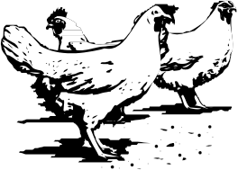About the Project:
Breeds # of Birds
Project Expenses
Date | Equipment, Health Care, Show  Expenses, etc. | Cost

Source of Birds:
home hatch
commercial hatchery
swap meet
mail order
other, describe

Total Value of Flock $_

Management Record
Month | Description of Work Done (Examples: Daily Care, Feeding, Handling) | Hours

Ways You Received Help This Year Include:
(check all that apply)
Exhibits in This Project:
Item Placing
(additional page may be added)

Attended project training offered by my club
Attended project training offered at the county level
Attended project training offered at District or State Level
Guidance from 4-H Leader/4-H Club
Guidance from Parent/Guardian/Other Adult
Reading and use of 4-H project guides
Reading and use of literature, books, audio visual resources
Own knowledge
Help from friends/other youth
Other (describe)

What did you learn or enjoy in the project this year?

What project related skill(s) would you like to learn or improve?
Explain why you selected the Poultry Project and how you feel about what you accomplished:

List at least 2 poultry/bird industry related careers that you can identify.
Are your family or friends interested in this project with you? Yes No

If yes, what do you do together?

Are you interested in a career related to the poultry industry?
Yes_ No_ Maybe_

Project Worth Statement

Has this project been worthwhile to you? Why or why not?

Revised 12/2007

