WINNEBAGO COUNTY

TRACTOR PROJECT RECORD FOR 20

Things I plan to do and learn this year in this project are: (complete this box between Jan. 1 — May 1) | Check When Done

Have you taken a tractor safety course? If yes, tell what you learned.

Date | Describe Expenses: equipment purchased, supplies, etc. | Cost

Ways You Received Help This Year Include:
(check all that apply)
Exhibits in This Project:
Item Placing
(additional page may be added)

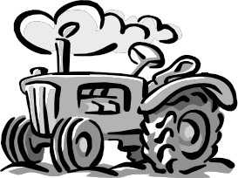
Attended project training offered by my club
Attended project training offered at the county level
Attended project training offered at District or State Level
Guidance from 4-H Leader/4-H Club
Guidance from Parent/Guardian/Other Adult
Reading and use of 4-H project guides
Reading and use of literature, books, audio visual resources
Own knowledge
Help from friends/other youth
Other (describe)

What did you enjoy most about the tractor project?

What did you enjoy least about the tractor project?

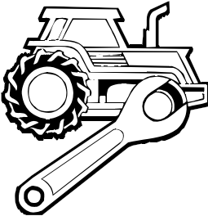What project related skill(s) would you like to learn or improve?
List at least 2 tractor industry related careers that you can identify.

Project Worth Statement
Are you interested in a career related to the tractor industry?
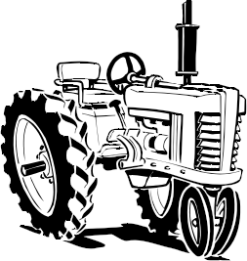Yes_ No_ Maybe_

Has this project been worthwhile to you? Why or why not?

Revised 11/2006

