WINNEBAGO COUNTY

WOODWORKING PROJECT RECORD FOR 20

Things I plan to do and learn this year in this project are: (complete this box between Jan. 1 — May 1) | Check When Done

List all the tools used this year: What new skills, techniques, tools or information did you learn this year?

Ways You Received Help This Year Include:
(check all that apply)
Exhibits in This Project:
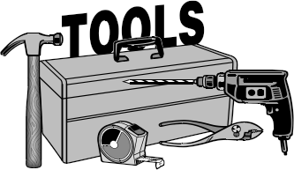Item Placing
(additional page may be added)

Attended project training offered by my club
Attended project training offered at the county level
Attended project training offered at District or State Level
Guidance from 4-H Leader/4-H Club
Guidance from Parent/Guardian/Other Adult
Reading and use of 4-H project guides
Reading and use of literature, books, audio visual resources
Own knowledge
Help from friends/other youth
Other (describe)

INDIVIDUAL ARTICLE RECORD
(Choose 1 item to report on in this project, please include pictures of all items on additional page.)

Item: Approximate hours to make: hours
What did you find most enjoyable in making this article?

Cost to make:

Wood $ Hardware (nails, screws
hinges, etc.) $ Sandpaper $
Finish (paint, varnish,
oil, wax, etc.) $ Other(s) (list)
$
$
$
$
Total Cost $ Estimated Value $
Estimate of Comparable
items if purchased $

What was the most difficult part of making this article?

Explain why this particular item was made &
where the pattern was obtained:
List at least 2 woodworking industry related careers that you can identify.

Are you interested in a career related to the woodworking industry?
Yes_ No_ Maybe_

What kind of wood did you use on this project?

What kind of finish did you apply and why?
What project related skill(s) would you like to learn or improve?

Project Worth Statement

Has this project been worthwhile to you? Why or why not?

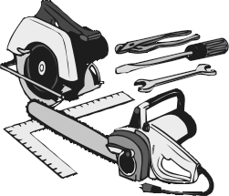Revised 11/2006

