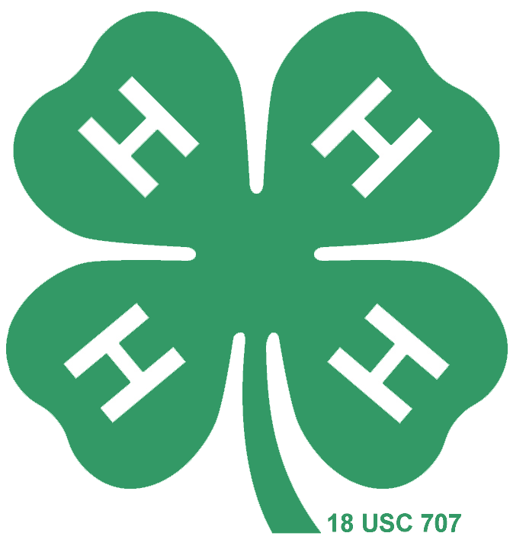
Raffle License – Request Form_____________________
Winnebago County 4-H Leaders’ Association
ANY group conducting a RAFFLE fundraiser (basket, bucket, 50/50, calendar, bingo, etc) MUST have a RAFFLE LICENSE from the STATE OF WISCONSIN Division of Gaming's Office of Charitable Gaming and follow all raffle guidelines and regulations. https://doa.wi.gov/Pages/LicensesHearings/RaffleLicense.aspx
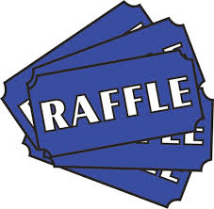
The Winnebago County 4-H Leaders’ Association purchases a RAFFLE LICENSE each year for raffle fundraisers like the Basket Raffle at Fair. The permit can be used by any Winnebago County 4-H group who is doing a raffle fundraiser (any fundraiser where an individual buys a ticket and a winner is drawn from the tickets). The License is good for one year from the date of purchase. Winnebago County 4-H clubs or groups can request use of this license by completing & emailing this request form or calling the Extension Office (920-232-1974).

- Requests for the use of the RAFFLE LICENSE must be made at least one week in advance, and will be granted on a first come first serve basis.
- Requestors must read and follow all State of Wisconsin Raffle/Gaming Guidelines, available on our website: https://winnebago.extension.wisc.edu/4h/resources/
This includes but is not limited to:
- Class A (multiple day raffles/ticket sales) must be pre-printed with required information – including License number (updated annually). Please contact Extension Office for assistance with this.
- Sold Class A tickets and calendars must be retained for one year after date on which the drawing is held.
- Organization shall maintain a list of the names and addresses of all persons winning prizes with a fair market value of $600 or more, and the prizes won, for at least 12 months after each raffle is conducted. Our recommendation is to keep a list of all winners in case of dispute.
- A licensed organization shall keep an electronic or paper copy of its license at each raffle drawing held.
- A financial report including expense, income and profit will be filed after each raffle
- All profits raised by a raffle must be used to further the purpose of the licensed organization.
- Raffle profits may not be used to benefit an individual or purpose not noted in your organization’s purpose. Example; a school may not raise funds to donate to the American Family Children Hospital or an individual student, teacher, or parent.

Requester :_________________________________________ Date of Request:_____________________________
Club/Group: ____________________________________________________________________________________

Fundraiser/Event: _______________________________________________________________________________

Location: _____________________________________________________ Date (s): _________________________

□ I am requesting the CLASS A License (multiple days of ticket sales – tickets must have license # on them)
□ I am requesting the CLASS B License (single day of ticket sales – generic tickets may be used)

Submit Requests to the Extension Office
arolph@co.winnebago.wi.us • 920-232-1974 • 625 E County Road Y • Suite 600 • Oshkosh, WI 54901

Office Use Only:

Approved by: _________________________________ Class A Tickets printed by: ____________________________________

Date Regulations & Copy of License sent to requestor: ____________________________________________________________

Date Final Financial Report & List of Winners Received:____________________________________________________________

Last updated 3/2020

